The time I played in Croke Park

I was 8 years old when I went with my Club Annascaul GAA to a LGFA event in Croke Park. There were only two teams from Kerry selected, Annascaul was picked along with Dingle. They gave us pink LGFA t-shirts that we had to wear all day.

We were divided into an older group and a younger group because we had so many players, I was in the younger group and my sister was in the older group. I remember just walking out on the field seeing the seats up so high remembering the Kerry team playing all Irelands here. We played games all day we played teams from Galway, Dublin, Mayo, Cork, Limerick and many more.

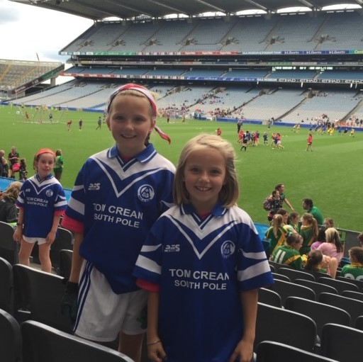

I remember being mid field for a while and looking around with the stand up so high and imagining playing there when I was older and having the stands full. All of the parents and siblings were there to cheer us on, after a while in our games Ella, Fia and Mary came to our side to play the last of our games with us.

We won our last game and had a big cheer, everyone who played got a gold designed medal. It was the best day of my life! My dad and mom loved seeing me and Ella play there.

By Mae.